Lab 2: Setting Up the Database Context for a Retail Store

Category Model:
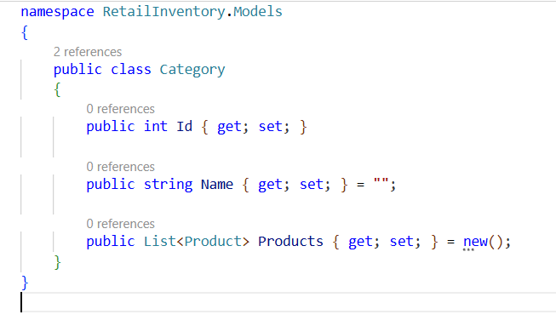

Product Model:
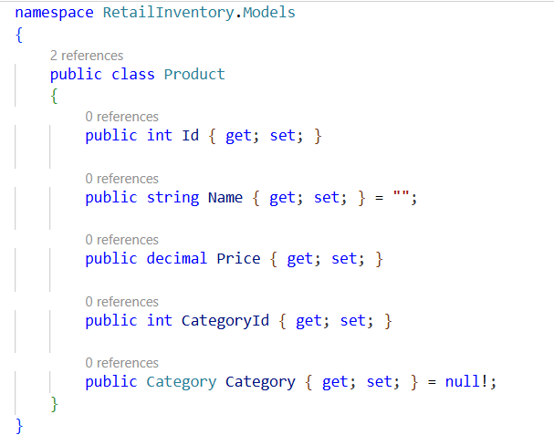

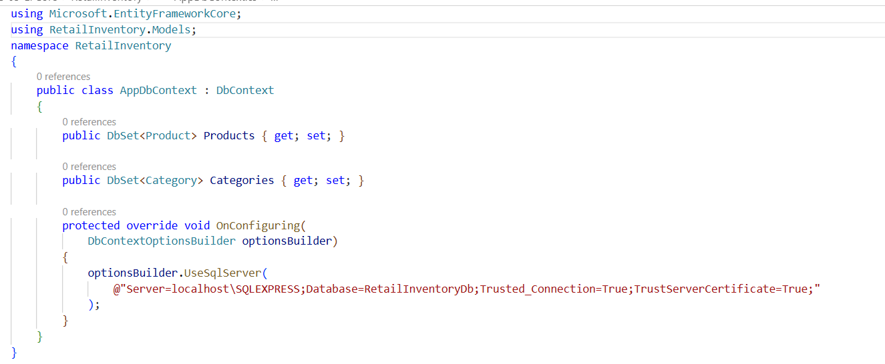
AppDbContext.cs:

Build Project:
dotnet build
Output:
